Business Analytics - Assignment -1

shiva gadila

2023-02-18

#Question - 1   
#Install the ISLR library using the command   
#install.packages(ISLR)

#Question -2   
#Calling the ISLR library, summary of carseats and finding the number of rows  
  
library(ISLR)  
summary(Carseats)

## Sales CompPrice Income Advertising   
## Min. : 0.000 Min. : 77 Min. : 21.00 Min. : 0.000   
## 1st Qu.: 5.390 1st Qu.:115 1st Qu.: 42.75 1st Qu.: 0.000   
## Median : 7.490 Median :125 Median : 69.00 Median : 5.000   
## Mean : 7.496 Mean :125 Mean : 68.66 Mean : 6.635   
## 3rd Qu.: 9.320 3rd Qu.:135 3rd Qu.: 91.00 3rd Qu.:12.000   
## Max. :16.270 Max. :175 Max. :120.00 Max. :29.000   
## Population Price ShelveLoc Age Education   
## Min. : 10.0 Min. : 24.0 Bad : 96 Min. :25.00 Min. :10.0   
## 1st Qu.:139.0 1st Qu.:100.0 Good : 85 1st Qu.:39.75 1st Qu.:12.0   
## Median :272.0 Median :117.0 Medium:219 Median :54.50 Median :14.0   
## Mean :264.8 Mean :115.8 Mean :53.32 Mean :13.9   
## 3rd Qu.:398.5 3rd Qu.:131.0 3rd Qu.:66.00 3rd Qu.:16.0   
## Max. :509.0 Max. :191.0 Max. :80.00 Max. :18.0   
## Urban US   
## No :118 No :142   
## Yes:282 Yes:258   
##   
##   
##   
##

nrow(Carseats)

## [1] 400

# The carseats dataset has 400 rows.

# Question -3   
# Finding the maxminum value of Advertising attribute.   
max(Carseats$Advertising)

## [1] 29

#Advertising attribute has 29 as its maxmimum value.

#Question - 4  
# Finding the IQR value of price attribute   
IQR(Carseats$Price)

## [1] 31

#Price Attribute has 31 as its IQR value

#Question - 5   
#Ploting the Sales over price and finding the correlation.  
  
library(ggplot2)  
  
ggplot(Carseats)+  
 aes(  
 x=Sales,  
 y=Price  
 )+  
 geom_point(shape="circle", size = 1.2, colour="orange")+  
 theme_minimal()

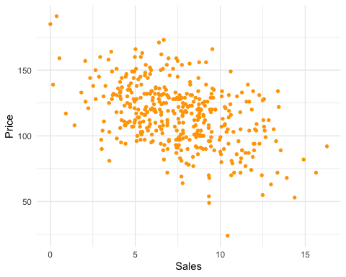

#Customers are more likely to purchase lower-priced car seats since there is no correlation between the number of units scored and the price of the seats.